Title: Bee distribution
Methods
This study is to investigate the abundance of the bee species Eulaema nigrita in the Brazilian Atlantic Forest, and two potential predictor variables (altitude and precipitation seasonality (Pseason = CV of monthly precipitation (%, *100)) are used. There are some other predictor variables like temperature seasonality (Tseason = 100*Sd of monthly temperature) and mean annual temperature (MAT = ºC*10). Temperature and precipitation exhibit different patterns and characteristics in their variability. Temperature tends to fluctuate around a mean value, and the standard deviation helps capture the extent of these fluctuations. On the other hand, precipitation can vary significantly in terms of both the amount and frequency, hence the use of CV to normalize this variability relative to the mean. The pairs function is first used to determine whether the bee distribution correlates with all different data sets. Normal glm is used to analyse the data set. Negative binomial algorithm is then used to compute the data when normal glm is not suitable. To plot the fitted regression line, the predicted values are back-transform. The generic predict function is used to obtain the predicted values on the data scale, and to construct a 95% confidence polygon.

Result:
The pairs resulted the altitude variable negative correlates with MAT (see supplementary figure 1). This study focuses on these two predictor variables, Pseason and altitude. Normal glm were first applied on these two variables, and the residual deviances were too high compared to the degrees of freedom. Therefore, negative binormial algorithm were used to compute the data. From the result calling with glm.nb(formula = dat$Eulaema_nigrita ~ dat$Pseason, init.theta = 0.6662838264, link = log), Precipitation seasons (more rain) positive influenced the bee distribution (Table 1 and Figure 1).

Table 1: Negative Binormial algorithm is performed on the bee distribution against Precipitation season

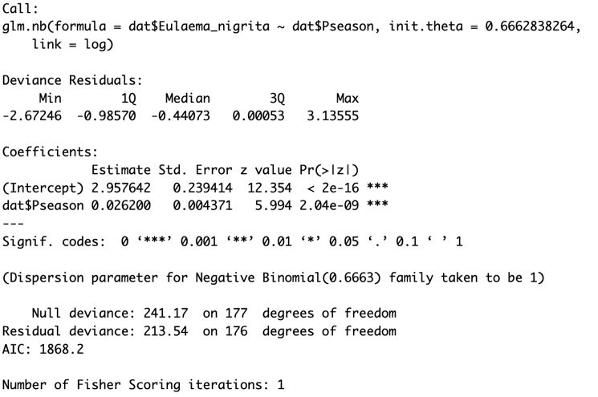

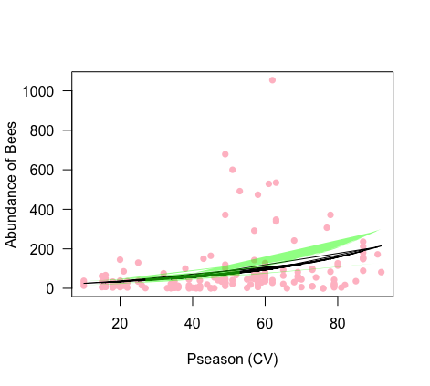
Figure 1: Bee distribution is positive affected by the amount of rains over the years

Table 2: Negative Binormial algorithm performed on bee distribution against Altitude

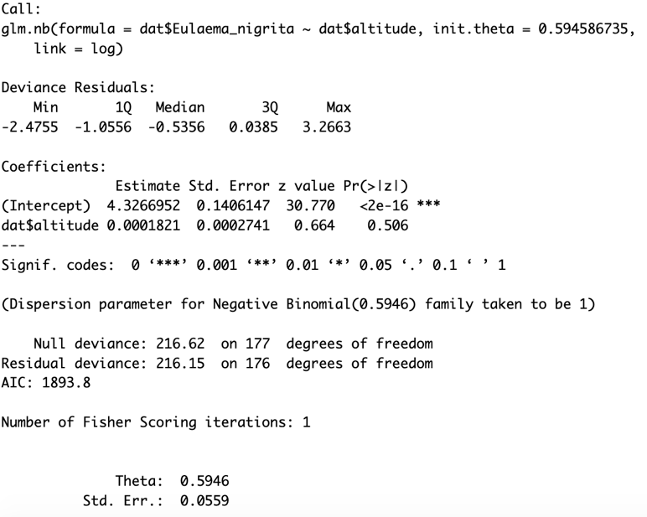

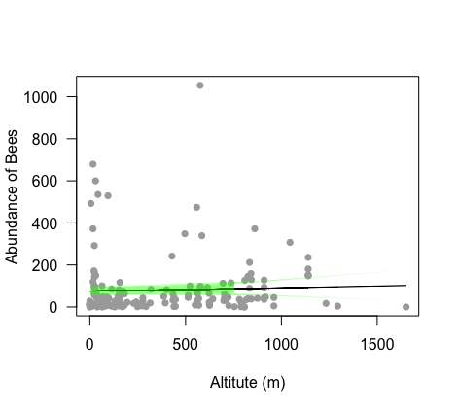
Figure 2: Bee distribution increases in lower altitude

The abundance of bee distribution was observed in lower altitude. Although the result from the negative binomial show almost no preference effects of bee distribution on the altitude variable (Table 2), but the computed confidence interval was stronger at the range of 0-200 m altitude (Figure 2). This result suggested that bees prefer lower altitude, as higher altitude may denote lower temperature in general.

Appendix:

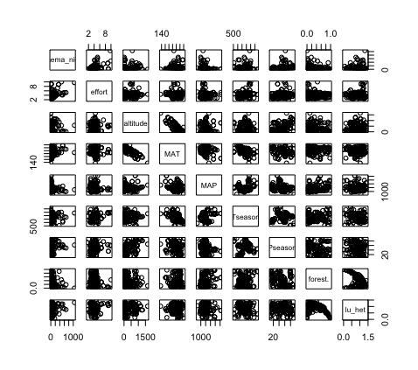
Supplementary Figure 1: pairs correlation of data set

